**PHARMAC CLINIC**

**FOR: PHARMAC CLINIC AND PHARMACY**

**PROJECT SCOPE**

**December 20, 2022**

**OVERVIEW**

1. **Project Background and Description**

PHARMAC CLINIC AND PHARMACY is a registered pharmaceutical in the republic of Kenya, with its main branch based at Ruaka, Kiambu County.

The pharmacy is growing very rapidly and as a result, there is an urgent need to automate most of its manual processes in order to: -

•Fasten the operational processes for all the entities concerned within it.

•Increase transparency at all levels.

•Increase and instill trust among entities involved within its system.

•Lower the turnaround time for its operations.

•Leverage existing technologies to promote growth of its branches and easier service delivery.

•Lower operational costs.

1. **Project Scope**

In order to achieve the above named, the project will implement 3-tier, responsive web-based application system that will be accessible over the internet through: -

•Smart phones – management and clients

•SMS and short-code - clients

•Small devices (ipad and ipad-like devices) - clients and management.

•Laptops, desktops and large system – clients and management.

1. **High-Level Requirements**

The system is web-based application. As such, any device with internet access and the latest browser, will be able to access it. In addition, there will be SMS capabilities that can be utilized by any device with SMS capabilities.

The new system must include the following:

•Ability to allow both internal and external users to access the application without downloading any software

•Ability to interface with the existing data warehouse application

•Ability to incorporate automated routing and notifications based on business rules

1. **Deliverables**

•Back-end software that is hosted in the cloud.

•UI Prototype for both client and management.

•Management web-based application, accessible through specific authorized computers.

•Clients responsive web-based application accessible.

•User documentation manual.

•Technical documentation

1. **Affected Parties**

•Management

•Clients

•Supplier

1. **Affected Business Processes or Systems**

•Patient registration

•Reception

•Transactions

•Doctors

•Pharmacy inventory

•Accounts status enquiries

1. **Implementation Plan**

The project will kick off with the implementation of stubs necessary to enable development of the prototype.

After the stubs, the UI prototype will be developed. Once the prototype has been developed, the pharmacy officials will go through it and approve of it. This stage is to ensure that all required functionalities have been factored and that the user experience (UX) is excellent.

After the UI prototype has been done, the stubs will be replaced with the business logic, starting with clients’ module, doctors’, pharmacy and patients’ then suppliers’ module last.

Email and SMS alerts will be integrated as part of modules development.

Signing off, commissioning and training will follow thereafter.

1. **Flow charts**

**Patient assessment and registration**

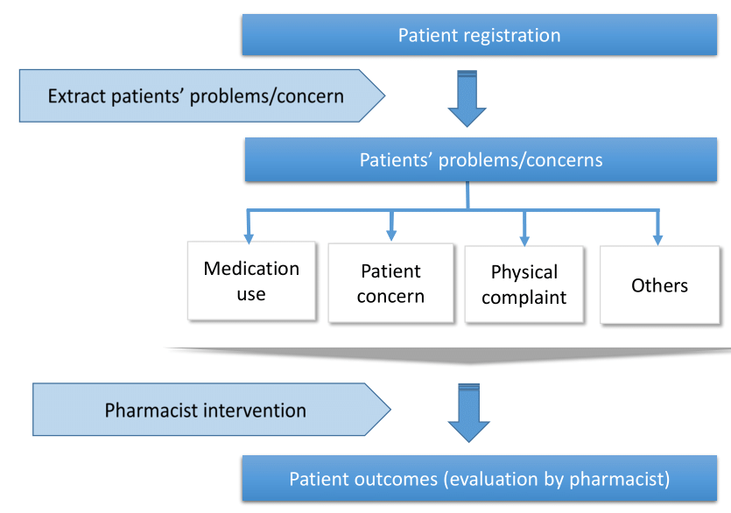

**Pharmacy**

